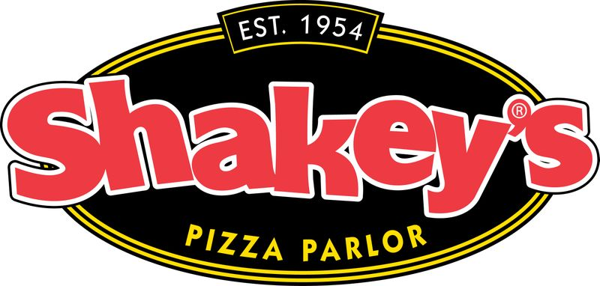
Shakey’ night is here
Shakey’s Pizza
6052 W. Olympic Blvd., Los Angeles, CA 90036
Olympic & Fairfax
Sponsored by Cheer and Dance Production


Thursday, September 6th
^{4:00pm-7:00pm}
Good food, music, fun, and friends.

Sponsored by LAHS Cheer and Dance Production
Tell them you are from LA HIGH when you go!

